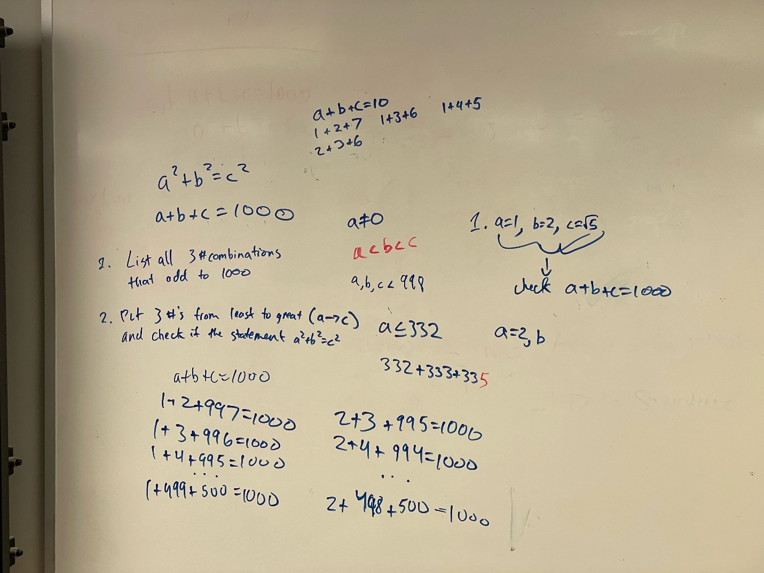

Ays

  
Our initial thought process was to find all combinations of 3 numbers that add up to 1000. After finding a combination that adds to 1000, we would just then quickly check if it satisfies the a^2 + b^2 = c^2 equation. If not, then it would iterate and keep on searching. We used a nested loop for this problem, with the first loop value representing a, and the second loop value representing the b value. The c value we set to be equivalent to 1000-a-b. Using this method, we found the Pythagorean triple, with values of a=200, b=375, and c=425. We are not sure if we set the time counter correctly, as our program produces the answer in around 1.8 milliseconds (we are not sure if that is fast or not, as the other group had average times of 16 milliseconds).